Table 1: assess16 calculations of B0 under three different formulations for R0 and Rbar.
 | Rbar=R0=theta(1) | Rbar=R0=theta(4) | R0=theta(1) & Rbar=theta(4)
wbar | 0.9937914 | 0.9937914 | 0.9937914
MPD
r0 | 2019.98 | – | 1638.92
rbar | – | 1011.3 | 3851.13
n0 | 6840.15757 | 3424.51478 | 5549.79309
B0 | 6797.68949 | 3403.25319 | 5515.33642
B2017 | 7705 | 7607 | 8709
Bavg | 8973.72 | 8767.36 | 8804.60
F2016 | 0.495903 | 0.474511 | 0.490467
Favg | 1.25418 | 1.258808 | 1.253432
10M MCMC
r0 | 1720.706 | – | 1356.93
rbar | – | 809.365 | 3122.26
B0 | 5790.575 | 2723.7 | 4566.405
B2017 | 7097 | 6642 | 7904
Bavg | 8574.06 | 8516.16 | 8341.3
F2016 | 0.523274 | 0.51717 | 0.516756
Favg | 1.274854 | 1.336467 | 1.337842

Note the differences in the estimates for B₂₀₁₇. This will affect the estimates of current stock status, depending on which formulation is chosen for the recruitment.

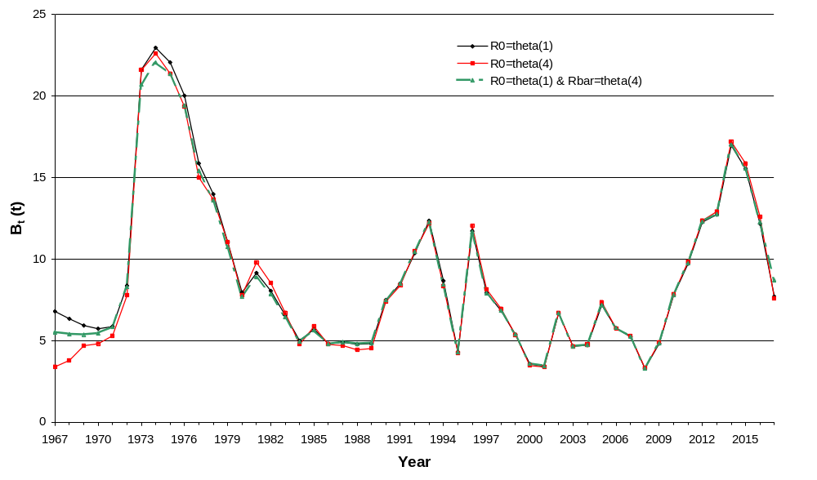
Figure 1: MPD assess16 plotted in biomass units using three alternative formulations for R0 and Rbar.
Note how estimating both R0 and Rbar allows the B0 estimate to neatly lie between the other two formulations.
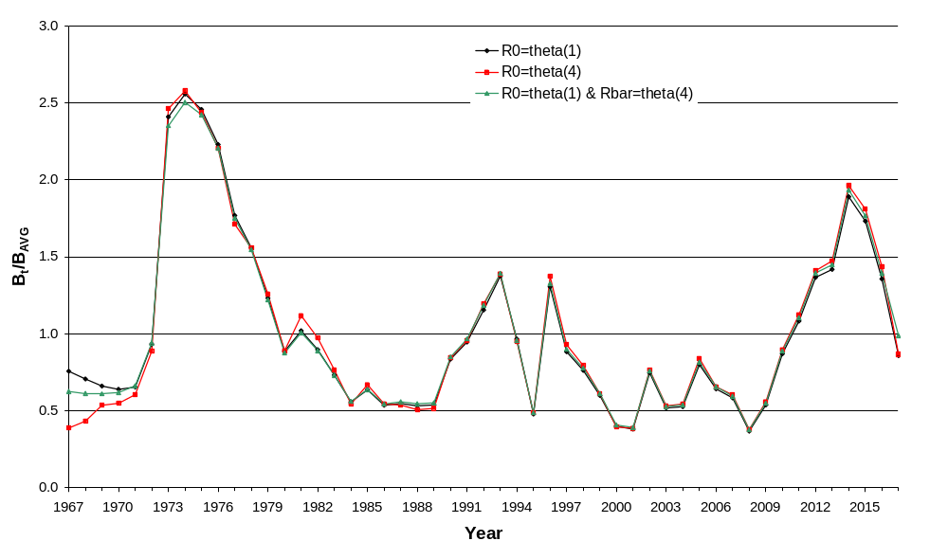
Figure 2: MPD assess16 plotted as depletion relative to the average biomass (see Table 1) from 1967–2016 under three different formulations for R0 and Rbar.
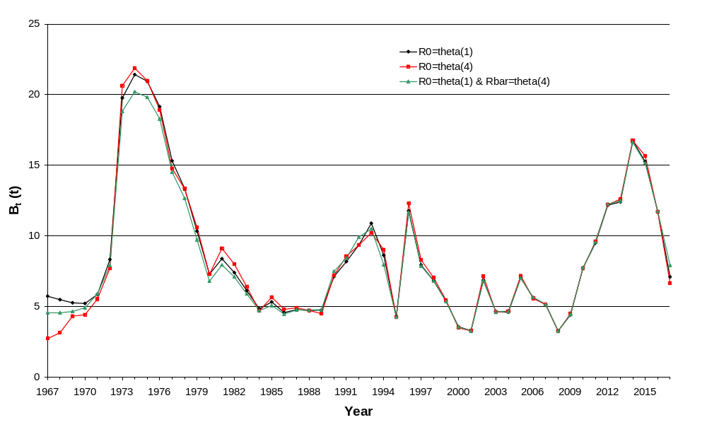
Figure 3: MCMC median assess16 plotted in biomass units using three alternative formulations for R0 and Rbar.
Note: I compared the 5% and 95% vectors as well but the relative relationships were the same.
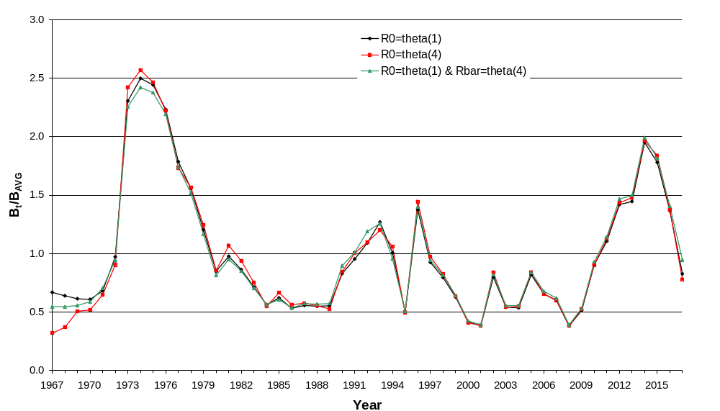
Figure 4: MCMC median assess16 plotted as depletion relative to the average biomass (see Table 1) from 1967–2016 under three different formulations for R0 and Rbar.
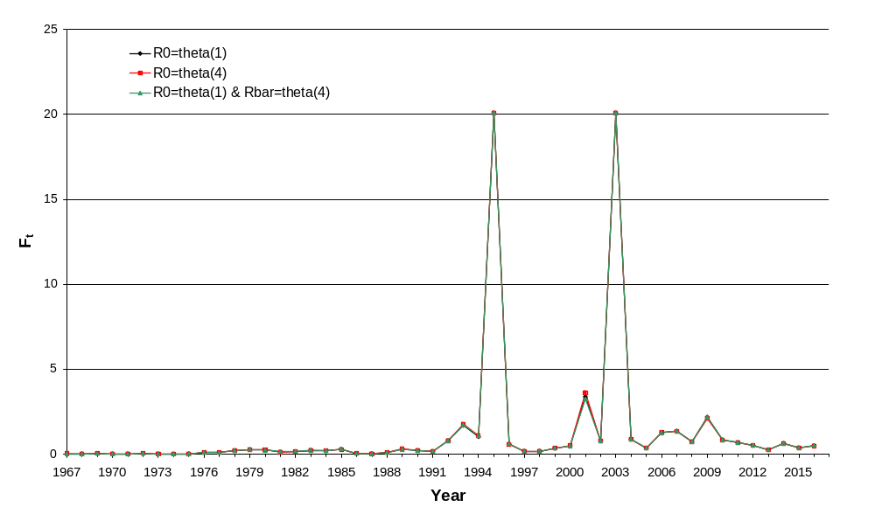
Figure 5: MPD assess16 plotted fishing mortality using three alternative formulations for R0 and Rbar.
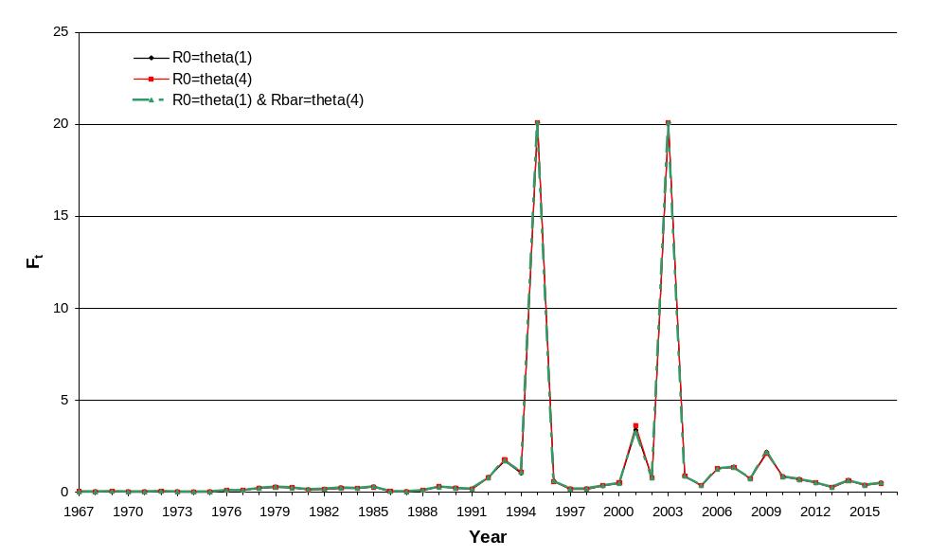
Figure 6: MCMC assess16 plotted fishing mortality using three alternative formulations for R0 and Rbar.

theta1 theta4 theta1+4
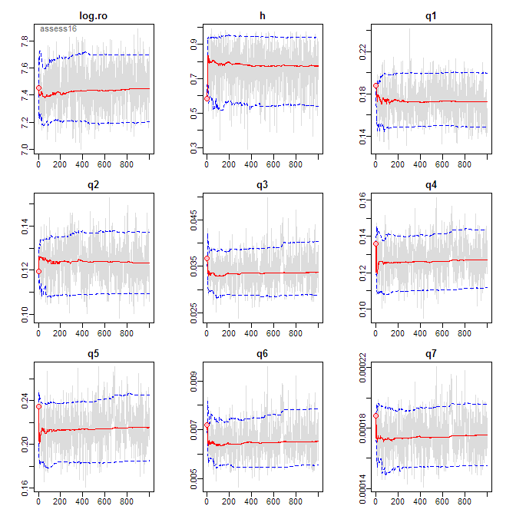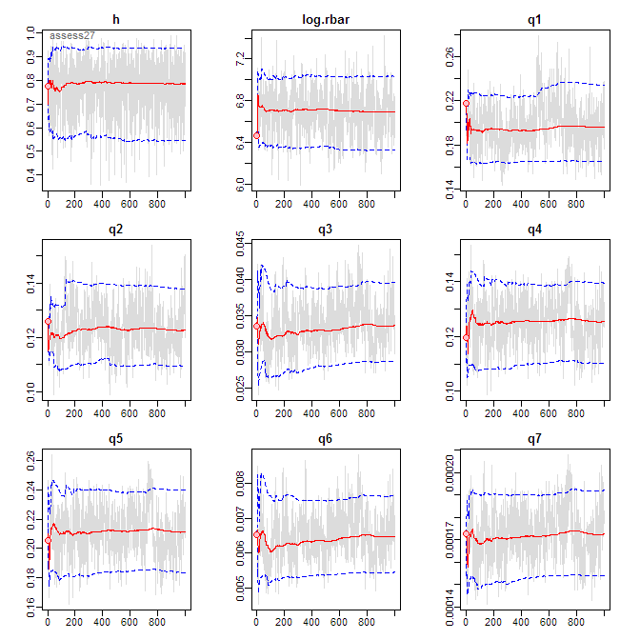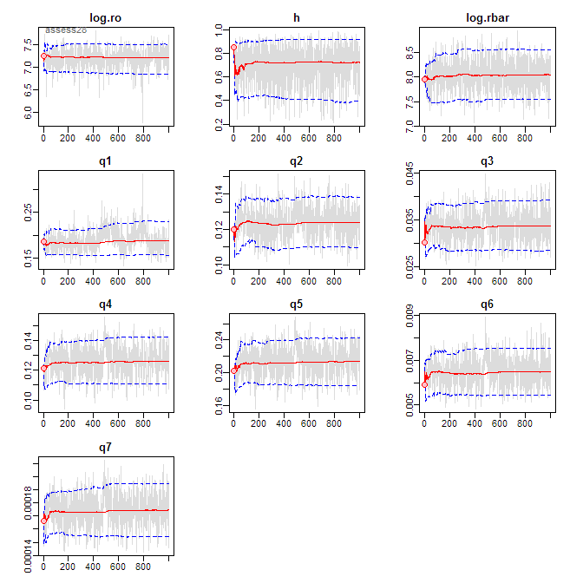
Figure 7: 10 M trace plots for assess16 for three alternative formulations for R0 and Rbar.
theta1 theta4 theta1+4
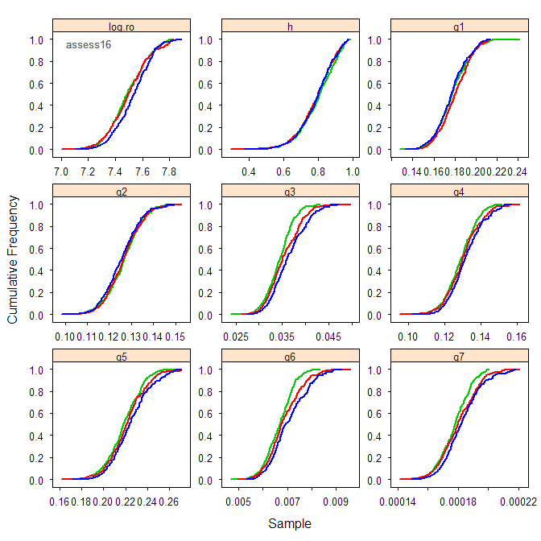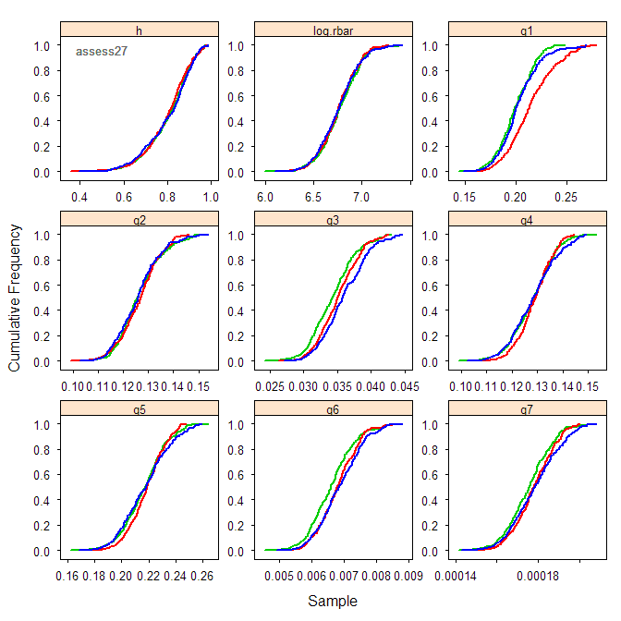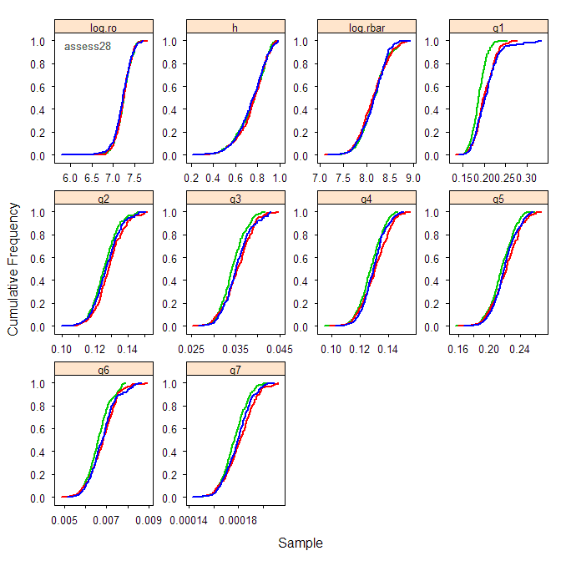
Figure 8: 10 M cumulative plots for assess16 for three alternative formulations for R0 and Rbar.

theta1 theta4 theta1+4
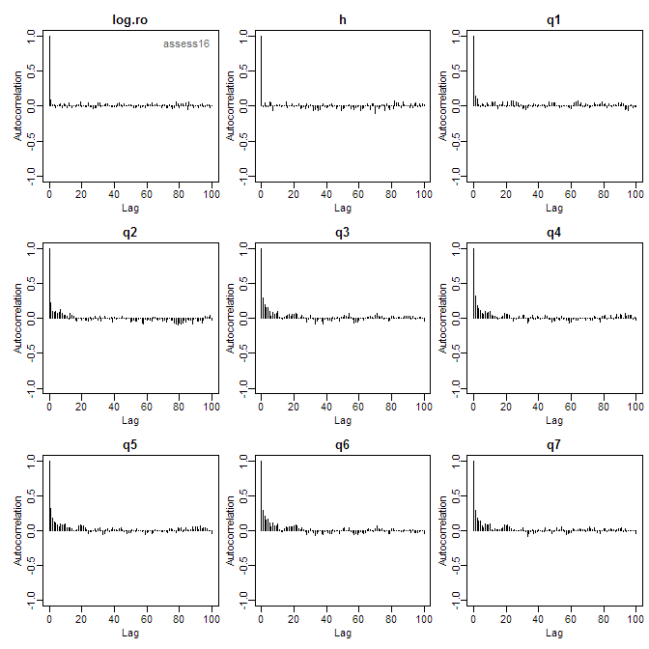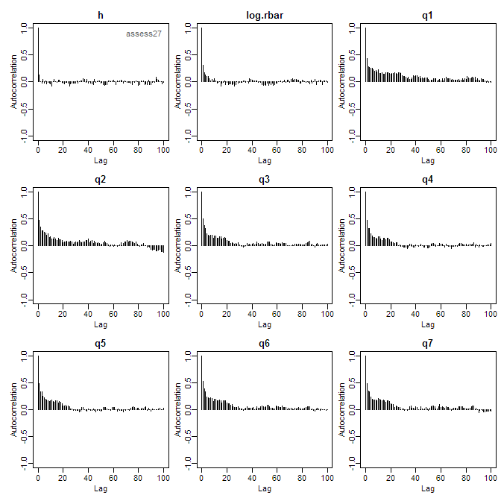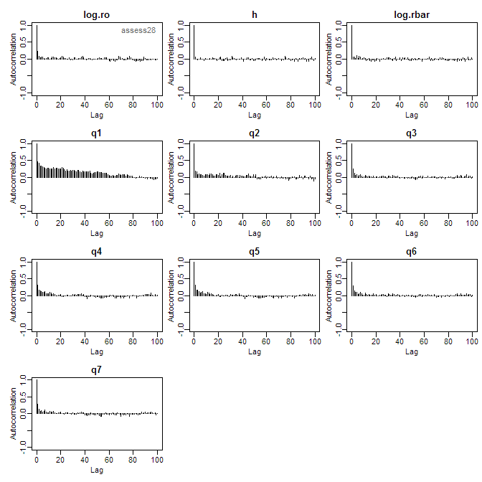
Figure 9: 10 M autocorrelation plots for assess16 for three alternative formulations for R0 and Rbar.
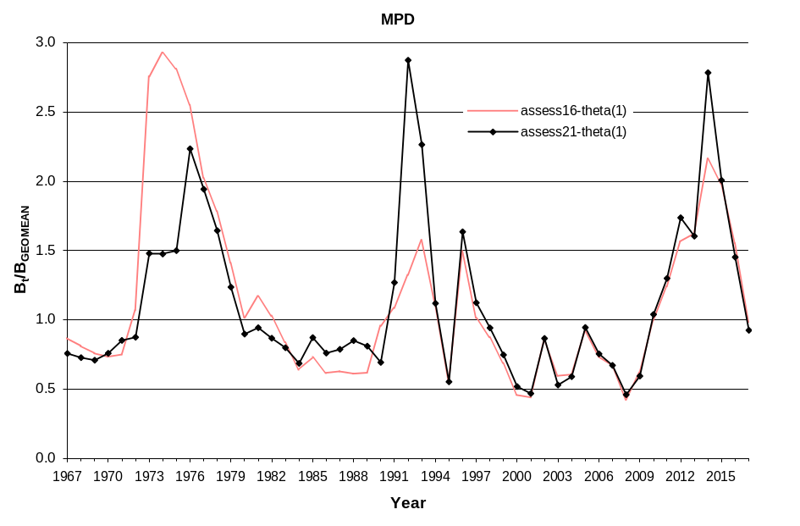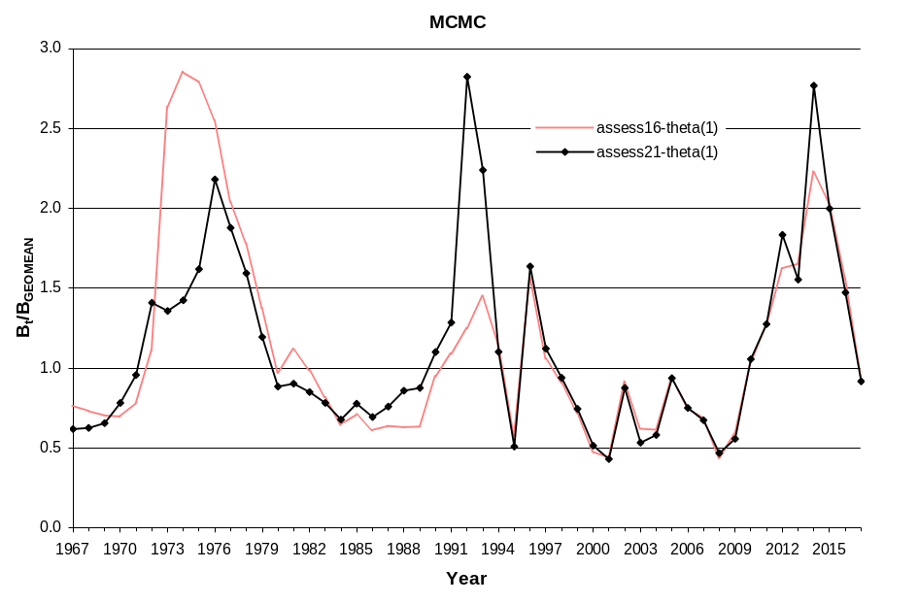
Figure 10: Plot showing the relationship between the biomass trajectories for assess16 (kage=3 using unsorted mean weight estimates) and assess21 (kage=4 using sorted mean weight estimates). All series have a geometric mean =1.0.

